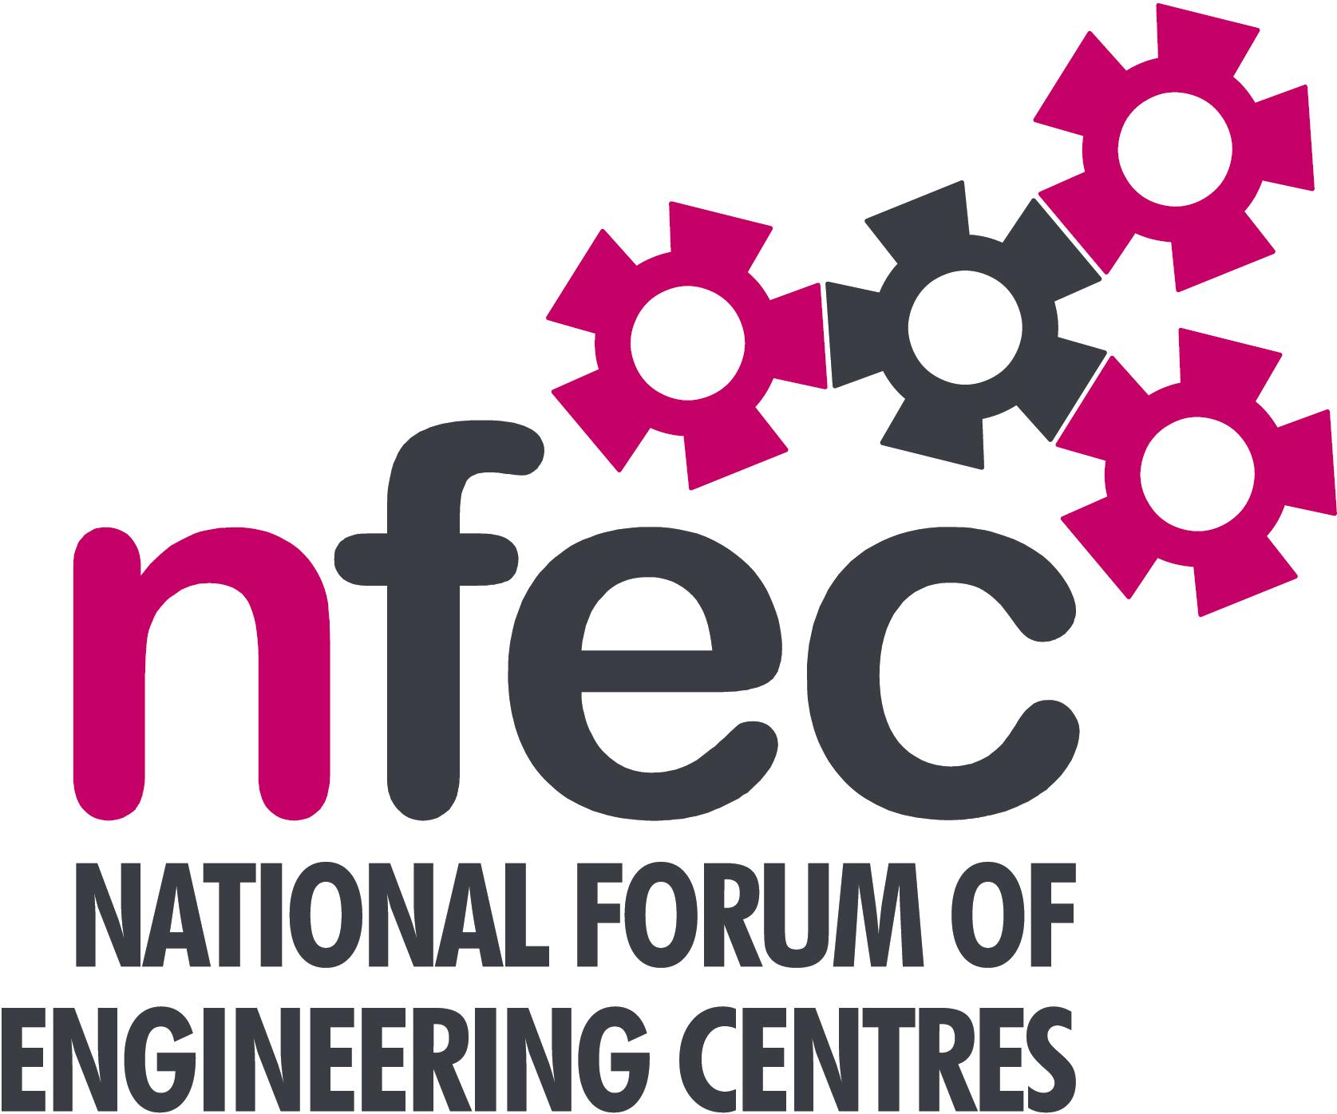
NFEC Spring 2018 North West Regional Seminar

Host: Riverside College

Friday 9th March 2018, 10.15am – 15.00 (Coffee from 10.00am)
Venue: Riverside College, Cronton Lane, Widnes, WA8 5WA
Telephone Number: 0151 424 1515

Programme

- Welcome and Introduction to the Seminar | Steve McAloone (NFEC North West Regional Coordinator)  Jo Hall – Riverside College | 10.15
- Current matters of concern relating to quality, content, structure, management and delivery of programmes of training and education in Engineering (not included on Agenda) - an opportunity for open discussion with a focus to distill key issues and plans for addressing them.  - Update on the Fabricator Trailblazer  - Qualifications and Awarding Bodies – Current developments and general issues.  - T level update  - Demonstration of Mindview software which converts brainstorming to mindmaps to reports and presentations.  Lunch and Demonstrations by Exhibitors  - Innovative Online Engineering Courses and Resources from Engineers Academy  Tour of facilities  - Women into STEM project being carried out at Riverside College  - Plenary session – Issues to note and agreed actions for NFEC  - Date, Place and Topics for next Seminar  Close  Entry is free to this seminar for members or to non-members present for a first attendance.There will be a charge for non members after this. A light buffet lunch will be provided and you will be able to see/discuss demonstrations of the latest available equipment and facilities for the delivery of learning in Engineering. | All Delegates/Steve McAloone  Terry Weston, The Engineering College  Pearson – Rachael Beasley and Jacqui Allen  Bob Millington, NFEC  Liam Pettit, Matchware Ltd  Andy Smith, The Engineers Academy  Jo Hall, Riverside College  All delegates/Steve McAloone  To book your place: Email: admin@nfec.org.uk  Phone: 07759 901229 | 10.20  10.35  11.00  11.15  11.40  12.00  13.00  14.10  14.45

